**Data Dictionary**

Rockbuster Stealth LCC



Prepared by Hannah Dilley

June 2021

Data Dictionary Contents

Entity Relationship Diagram 3

Fact Tables 4

film_actor 4

film_category 4

inventory 4

payment 4

rental 4

store 5

Dimension Tables 5

actor 5

address 5

category 5

city 5

country 6

customer 6

film 6

language 6

staff 7

Key:

|  |  |
| --- | --- |
| **🔑** | Primary Key |
| 🡵 | Foreign Key |
| 🡶 | Relation Key |

### Rockbuster Storyboard URL:

<https://public.tableau.com/app/profile/hannah.dilley/viz/RockbusterStealthLCC-On-lineFilmRentalAnalysis/Story1>

# Entity Relationship Diagram

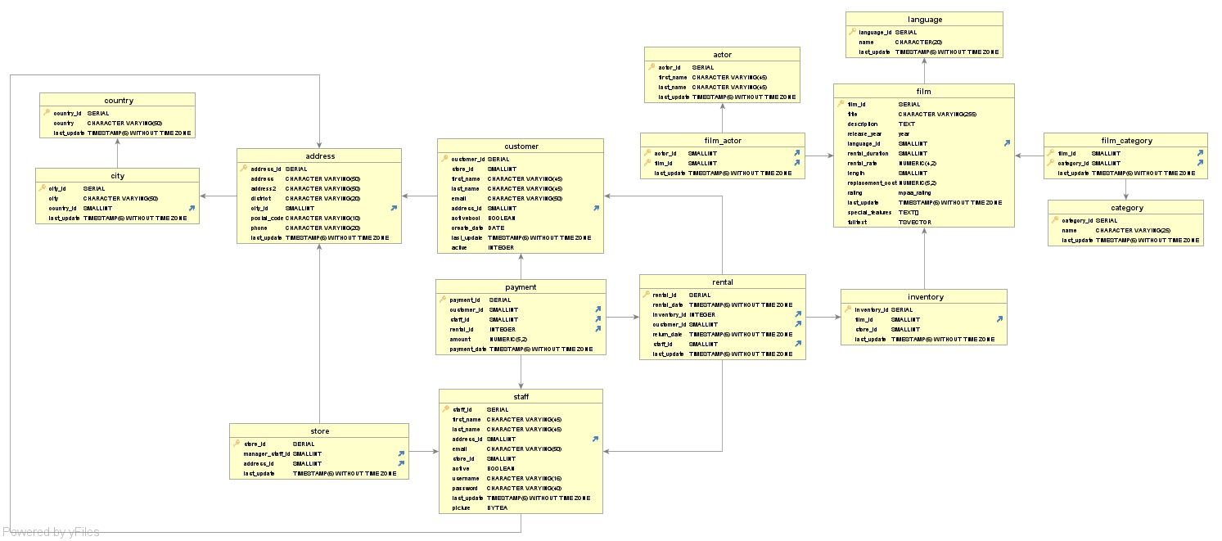

# Fact Tables

Identified by the columns generally being made up of only Keys and metrics, usually containing Foreign Keys which are linked to Primary Keys in other tables.

### film_actor

|  |  |  |
| --- | --- | --- |
| **Column** | **Data Type** | **Description** |
| **🔑** actor_id | small INT | 🡵Links to actor table |
| **🔑** film_id | small INT | 🡵Links to film table |
| last_update | timestamp (6) without timezone | Last updated date |

### film_category

|  |  |  |
| --- | --- | --- |
| **Column** | **Data Type** | **Description** |
| **🔑** film_id | small INT | 🡵Links to film table |
| **🔑** category_id | small INT | 🡵Links to category table |
| last_update | timestamp (6) without timezone | Last updated date |

### inventory

|  |  |  |
| --- | --- | --- |
| **Column** | **Data Type** | **Description** |
| 🡶**🔑** inventor_id | serial | Unique sequential counter  Link from rental table |
| film_id | small INT | 🡵Links to film table |
| store_id | small INT | Store ID |
| last_update | timestamp (6) without timezone | Last updated date |

### payment

|  |  |  |
| --- | --- | --- |
| **Column** | **Data Type** | **Description** |
| **🔑** payment_id | serial | Unique sequential counter |
| customer_id | small INT | 🡵Links to customer table |
| staff_id | small INT | 🡵Links to staff table |
| rental_id | integer | 🡵Links to rental table |
| amount | numeric (5,2) | Payment amount in format $00000.00 |
| last_update | timestamp (6) without timezone | Last updated date |

### rental

|  |  |  |
| --- | --- | --- |
| **Column** | **Data Type** | **Description** |
| 🡶**🔑** rental_id | serial | Unique sequential counter  Link from payment table |
| rental_date | timestamp (6) without timezone | Date of rental |
| inventory_id | integer | 🡵Links to inventory table |
| customer_id | small INT | 🡵Links to customer table |
| return_date | timestamp (6) without timezone | Date rental returned |
| staff_id | small INT | 🡵Links to staff table |
| last_update | timestamp (6) without timezone | Last updated date |

### store

|  |  |  |
| --- | --- | --- |
| **Column** | **Data Type** | **Description** |
| **🔑** store_id | serial | Unique sequential counter |
| manager_staff_id | small INT | 🡵Links to staff table |
| address_id | small INT | 🡵Links to address table |
| last_update | timestamp (6) without timezone | Last updated date |

# Dimension Tables

### actor

|  |  |  |
| --- | --- | --- |
| **Column** | **Data Type** | **Description** |
| 🡶**🔑** actor_id | serial | Unique sequential counter  Link from film_actor table |
| first_name | char var (45) | Actor’s first name |
| last_name | char var (45) | Actor’s last name |
| last_update | timestamp (6) without timezone | Last updated date |

### address

|  |  |  |
| --- | --- | --- |
| **Column** | **Data Type** | **Description** |
| 🡶**🔑** address_id | serial | Unique sequential counter  Link from customer, store & staff tables |
| address | char var (50) | Address line1 |
| address2 | char var (50) | Address line2 |
| district | char var (20) | District |
| city_id | small INT | 🡵Links to city table |
| postal_code | char var (10) | Postcode |
| phone | char var (20) | Phone number |
| last_update | timestamp (6) without timezone | Last updated date |

### category

|  |  |  |
| --- | --- | --- |
| **Column** | **Data Type** | **Description** |
| 🡶**🔑** country_id | serial | Unique sequential counter  Link from film_category table |
| name | char var (50) | Category name |
| last_update | timestamp (6) without timezone | Last updated date |

### city

|  |  |  |
| --- | --- | --- |
| **Column** | **Data Type** | **Description** |
| 🡶**🔑** city_id | serial | Unique sequential counter  Link from address table |
| city | char var (50) | City name |
| country_id | small INT | 🡵Links to country table |
| last_update | timestamp (6) without timezone | Last updated date |

### country

|  |  |  |
| --- | --- | --- |
| **Column** | **Data Type** | **Description** |
| 🡶**🔑** country_id | serial | Unique sequential counter  Link from city table |
| country | char var (50) | Country name |
| last_update | timestamp (6) without timezone | Last updated date |

### customer

|  |  |  |
| --- | --- | --- |
| **Column** | **Data Type** | **Description** |
| 🡶**🔑** customer_id | serial | Unique sequential counter  Link from rental & payment tables |
| store_id | small INT | Store ID |
| first_name | char var (45) | Customer first name |
| last_name | char var (45) | Customer last name |
| email | char var (50) | email address |
| address_id | small INT | 🡵Links to address table |
| activebool | Boolean | Active flag: true or false |
| create_date | date | Date record created |
| last_update | timestamp (6) without timezone | Last updated date |
| active | INT | Active flag: 1 or 0 |

### film

|  |  |  |
| --- | --- | --- |
| **Column** | **Data Type** | **Description** |
| 🡶**🔑** film_id | serial | Unique sequential counter  Link from film_actor, inventory & film_category |
| title | char var (255) | Film title |
| description | text | Film description |
| release_year | year | Year of release |
| language_id | small INT | 🡵Links to language table |
| rental_duration | small INT | Length of rental in days |
| rental_rate | numeric (4,2) | Cost of rental $0000.00 |
| length | small INT | Duration of film in minutes |
| replacement_cost | numeric (5,2) | Cost to replace film $00000.00 |
| rating | mpaa_rating | Film suitability rating, e.g., PG, 15, 18, etc. |
| last_update | timestamp (6) without timezone | Last updated date |
| special_features | text[] | Description of film special features |
| fulltext | TS vector | Search string text |

### language

|  |  |  |
| --- | --- | --- |
| **Column** | **Data Type** | **Description** |
| 🡶**🔑** language_id | serial | Unique sequential counter  Link from film table |
| name | char (20) | Language |
| last_update | timestamp (6) without timezone | Last updated date |

### staff

|  |  |  |
| --- | --- | --- |
| **Column** | **Data Type** | **Description** |
| 🡶**🔑** staff_id | serial | Unique sequential counter  Link from store, rental & payment tables |
| first_name | char var (45) | Staff first name |
| last_name | char var (45) | Staff last name |
| address_id | small INT | 🡵Links to address table |
| email | char var (50) | email address |
| store_id | small INT | Store ID |
| active | Boolean | Active flag |
| username | char var (16) | Login details: User name |
| password | char var (40) | Login details: Password |
| last_update | timestamp (6) without timezone | Last updated date |
| picture | byte A | Staff picture, binary storage |